Airline Reservation System
Abstract
This project presents the design and implementation of a Flight Reservation System using MySQL, aimed at managing flights, customers, seat inventory, and bookings in a relational-database environment. The system consists of normalized tables for flights, passengers (customers), bookings, and seats, with integrity constraints and triggers to maintain consistency of available seats upon booking and cancellation. Sample flight and booking data are inserted to demonstrate typical operations, such as flight search, seat availability check, booking creation, and cancellation. To support reporting, views and SQL queries enable generation of booking summaries and revenue estimates. This system serves as a mini-guide for building a robust back-end for airline reservations using relational database techniques, suitable for educational or prototype use in MySQL Workbench.

Introduction
In the modern era of air travel, efficient management of flight schedules, seat availability, and customer bookings is critical for both airlines and passengers. An airline reservation system, backed by a reliable relational database, enables centralized storage and retrieval of flight-related data, customer information, booking transactions, and seat inventories. Such a system eliminates many of the inefficiencies and inconsistencies inherent in manual booking processes, and supports real-time operations such as seat allocation, booking cancellation, and reporting.

Used Tools : MySQL

Step-by-Step Process
- Set Up the Environment
  - Install MySQL Server
  - Open MySQL Workbench and connect to your MySQL server.
  - Create a new schema (database) in Workbench.
- Design the Database Schema
  - In MySQL Workbench, create a new model (File → New Model).
  - Define your tables: Flights, Passengers, Bookings, Seats.
  - Define each table’s columns: primary keys, data types, NOT NULL, auto-increment, etc.
  - Define foreign key relationships (e.g., Bookings → Flights, Bookings → Customers) visually using Workbench’s relationship tools.
  - Add other objects like views, stored procedures in the same model.

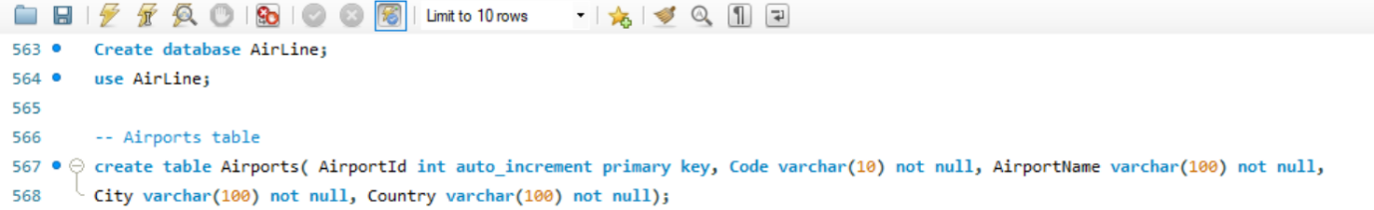

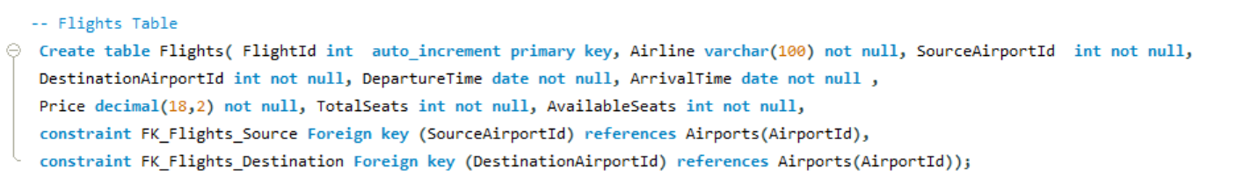

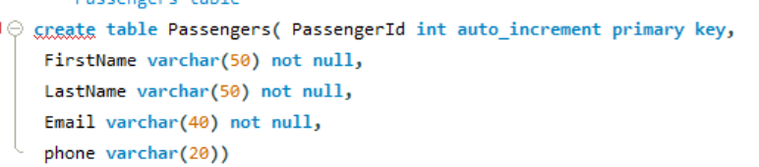

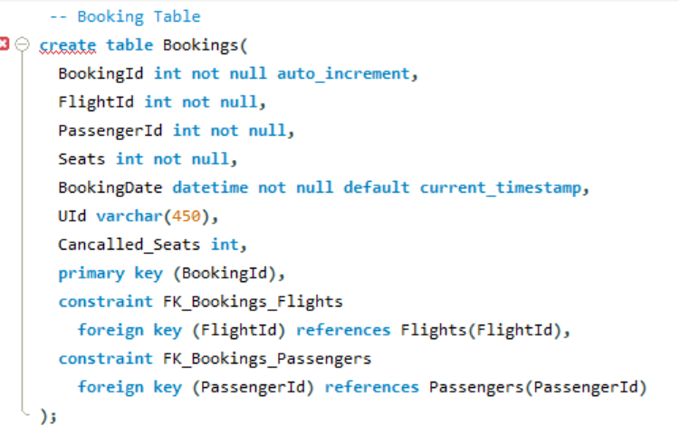
- Normalize the Schema and Add Constraints
  - Review your design to ensure normalization.
  - Add constraints: primary key, foreign key, unique constraints, check constraints as needed.
  - Define data types carefully for efficiency and correctness.
- Forward Engineer to Create the Physical Database
  - Once your model is ready, use “Database → Forward Engineer” in MySQL Workbench to generate DDL (SQL) to create the actual schema in your MySQL server.
  - Review the generated SQL script, and then execute it to create tables on the live server.
- Insert Sample Data
  - Write INSERT statements to populate tables with sample data: flights, passengers, seat inventory, booking records.
  - Make sure sample data covers various scenarios: bookings, cancellations, different flights, customers, etc.
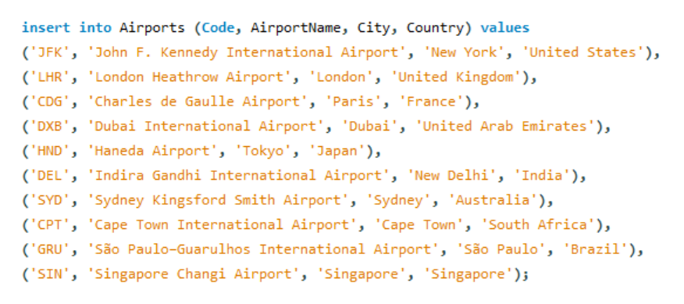

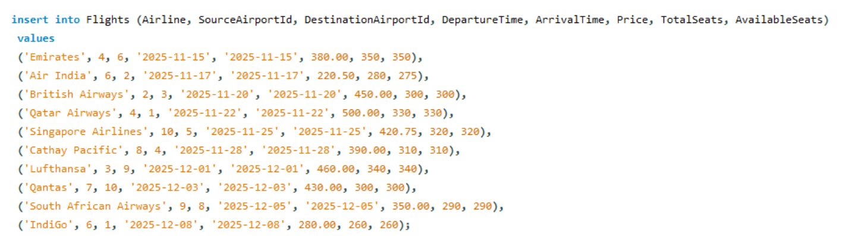
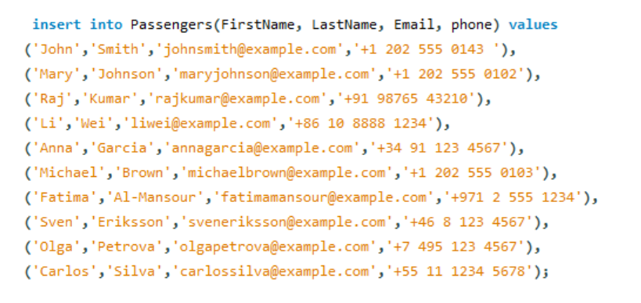
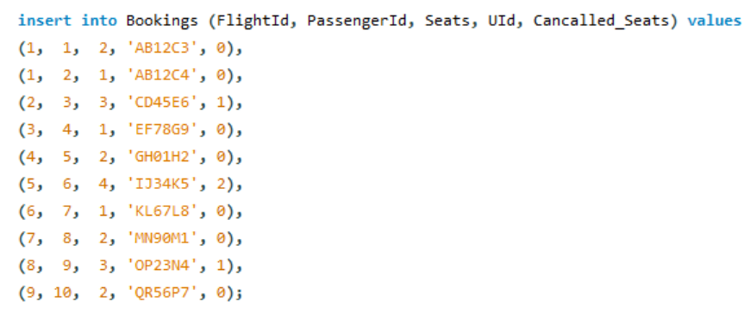
- Write Core Queries / Views
  - Flight Search: Query to search flights (e.g., by source, destination, date).
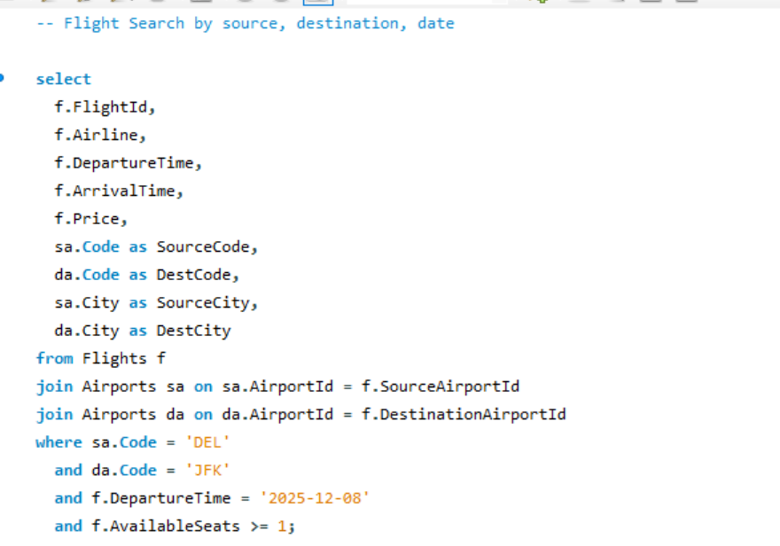
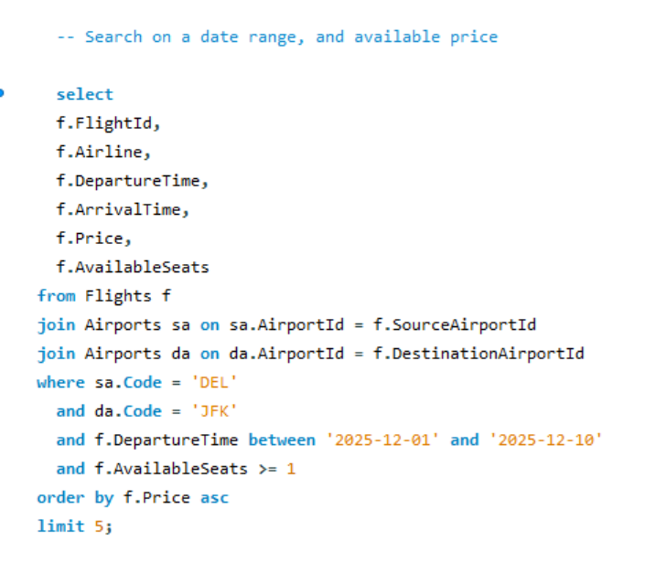
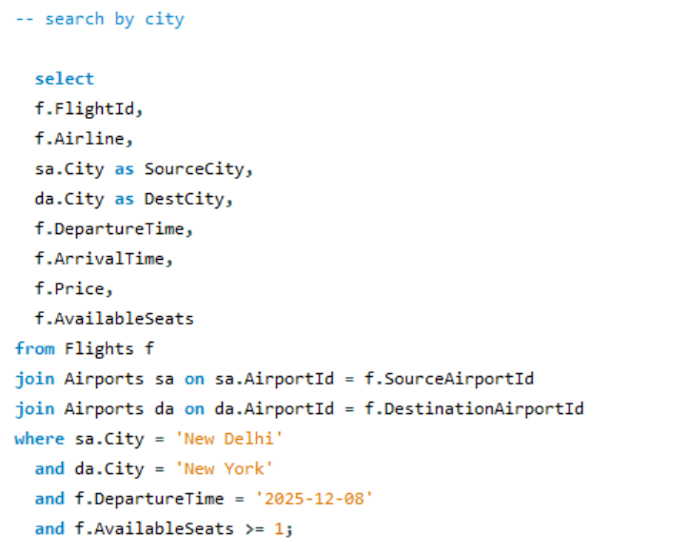
  - Available Seats: Query or view to compute how many seats are still free on a flight (TotalSeats – BookedSeats + CancelledSeats, etc.).
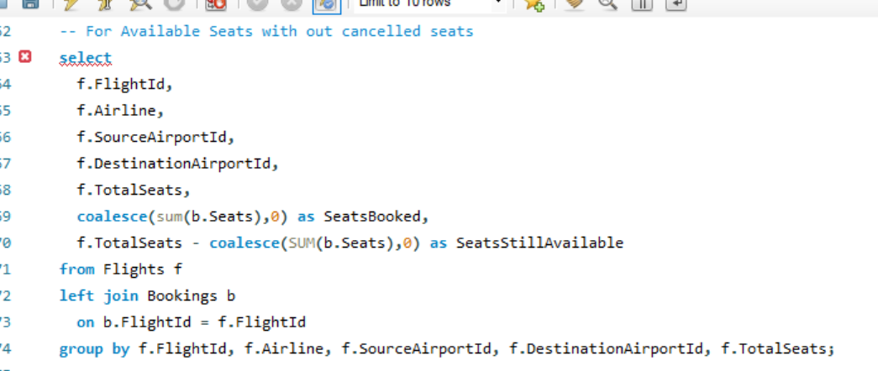
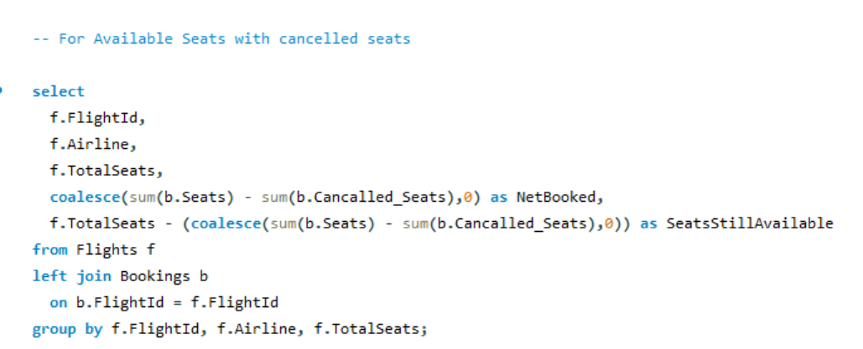
  - Create views for commonly used logic, e.g.:
    - AvailableFlightsView — flights with non-zero available seats
    - BookingSummaryView — per-flight booking summary

- Implement Business Logic with Triggers
  - Write AFTER INSERT trigger on Bookings to reduce available seats when a booking is made.
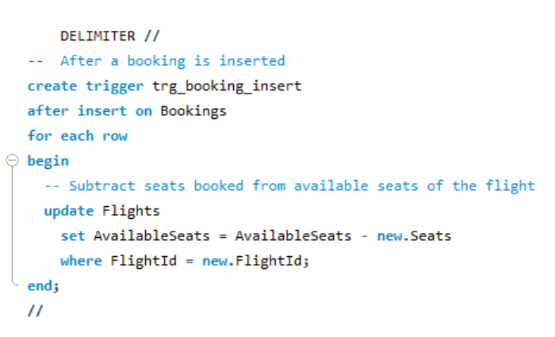
  - Write AFTER UPDATE trigger on Bookings to handle cancellations (updating available seats when Cancelled_Seats changes).
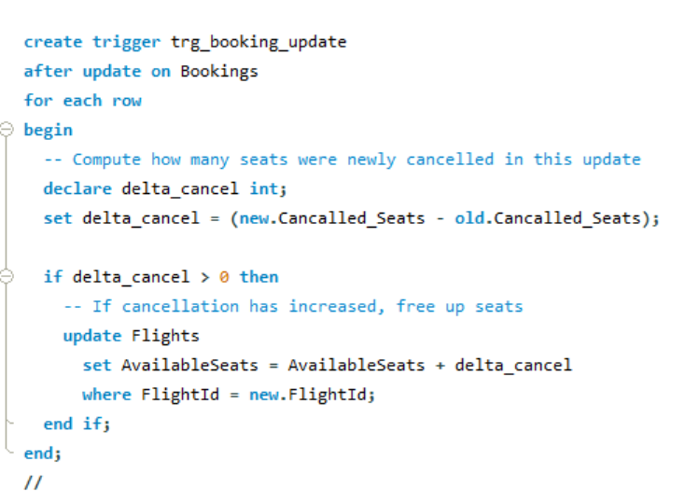
- Generate Reports / Summary
  - Write summary SQL queries for:
    - Bookings per flight
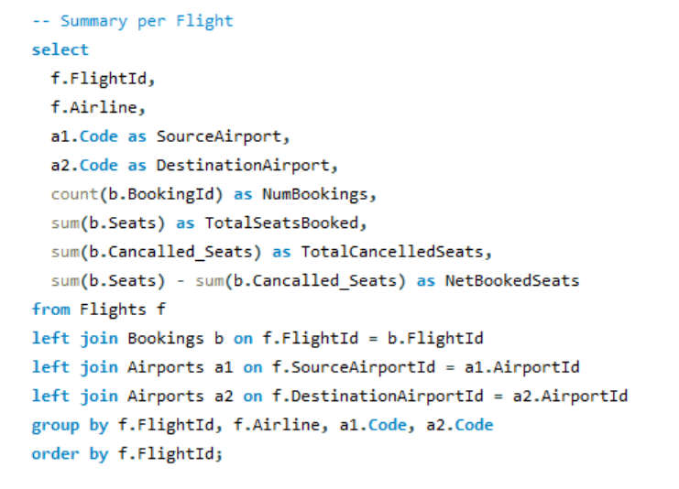
    - Revenue per flight (if price is per seat)
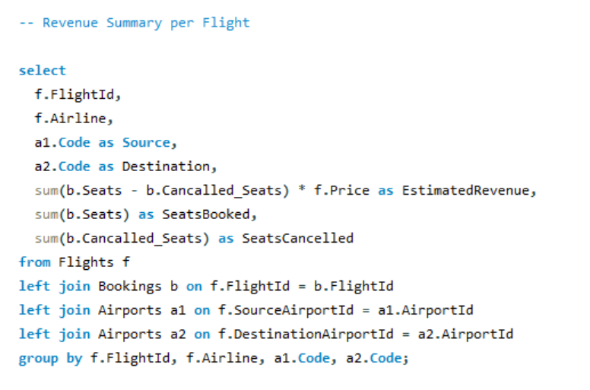
    - Monthly booking trends (group by booking date)
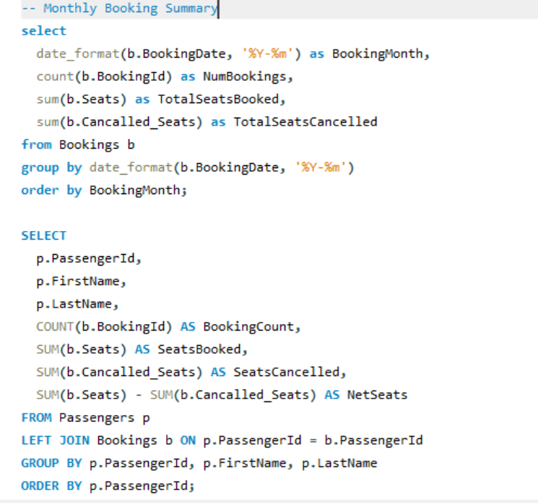

    - Customer-wise booking summary
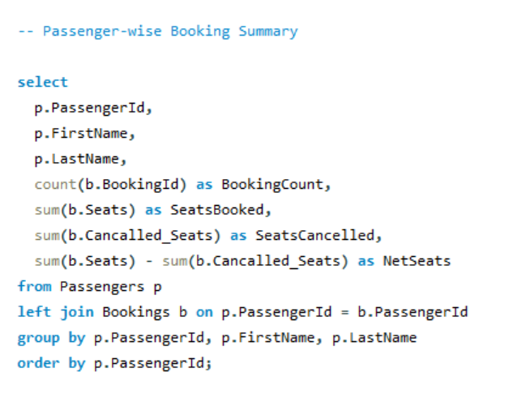

- Test and Validate
  - Test typical scenarios:
    - Book a new seat → check availability decreases
    - Cancel some seats → verify availability increases
    - Over-booking: attempt booking when no seats available
  - Validate referential integrity: foreign keys, cascading deletes, constraints.

Conclusion
The Airline Reservation System successfully demonstrates a complete SQL-based solution by designing a normalized database schema, managing flights and bookings with constraints and triggers, retrieving real-time seat availability and flight search results through optimized queries, and generating booking summaries that ensure accurate, automated, and efficient reservation processing.

